NAME: KHUBAN AZEEMI
SEMESTER: 1st
SESSION: 2025
DEPARTMENT: MATHEMATICS
TOPIC: MECHANICS BEHIND EARTHQUAKES AND BUILDING SAFETY

MECHANICS BEHIND EARTHQUAKES AND BUILDING SAFETY
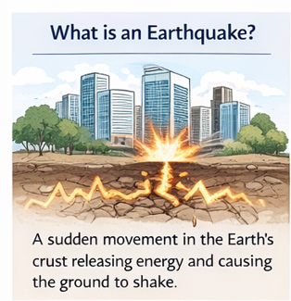
What is an Earthquake?
An earthquake is the shaking of the ground caused by sudden movements of the Earth’s crust. These movements release energy in the form of waves that spread in all directions. Earthquakes can be small and hardly noticeable or very strong and destructive.

Why Earthquakes Happen
- Tectonic Plate Movements
The Earth’s outer layer, called the crust, is divided into large pieces called tectonic plates. When these plates move, collide, or slide past each other, stress builds up. When the stress is released, it causes an earthquake.
- Volcanic Activity
When magma rises through the crust, it can push the ground and create small or large earthquakes.
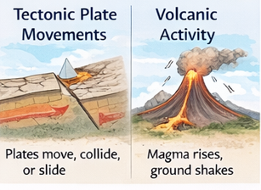
- Human Activity
Large construction projects, mining, and explosions can also trigger minor earthquakes.

What is Mechanics?
Mechanics is the branch of physics that studies motion, forces, and how objects react to forces. In earthquakes, mechanics helps us understand how the Earth moves and how buildings respond to the shaking.
Mechanics Behind Earthquakes
Earthquakes produce mechanical waves that transfer energy through the ground:
- Primary Waves (P-waves) – Fastest waves, move through solids, liquids, and gases, push and pull the ground.
- Secondary Waves (S-waves) – Slower waves, move only through solids, shake the ground side to side or up and down.
- Surface Waves – Travel along the Earth’s surface and cause the most damage to buildings and structures.
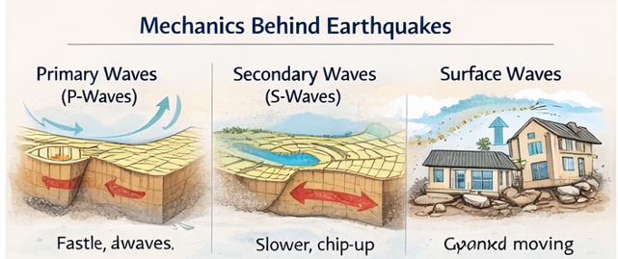

How Earthquakes Cause Damage
- Shaking of buildings, roads, and bridges
- Cracks in walls, floors, and foundations
- Collapse of weak or poorly designed buildings
- Damage to pipelines, electrical lines, and other infrastructure
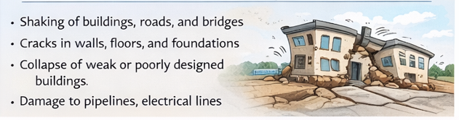

Forces Applied on Buildings During Earthquakes
- Lateral (Sideways) Forces – Cause buildings to sway left and right.
- Vertical Forces – Push the building up and down.
- Torsional (Twisting) Forces – Make the building twist if the structure is not uniform.
- Inertia – Buildings resist sudden motion, but inertia can increase stress on the structure.
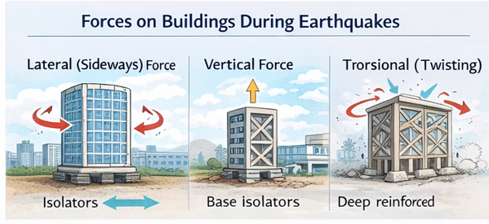

What is Building Safety? Why is it Needed?
Building safety means designing and constructing buildings to resist earthquake forces and reduce damage. Safety is needed to save lives, prevent economic loss, and protect important infrastructure.
How to Ensure Safety During Earthquakes
- Flexible Structures – Buildings that can bend slightly without breaking are safer.
- Base Isolation – Shock absorbers between the ground and building reduce vibrations.
- Strong Foundations – Deep and reinforced foundations make buildings stable.
- Lightweight Materials – Reduce the forces acting on buildings during shaking.
- Cross Bracing and Shear Walls – Strengthen buildings against side-to-side motion.
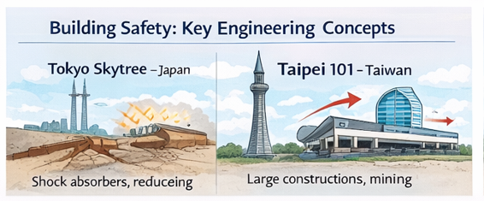
- Earthquake Drills – Teach people how to act during earthquakes to reduce injuries.

Engineering Safety Concepts
- Engineers study forces, materials, and structure behavior to design earthquake-resistant buildings.
- Buildings in earthquake-prone areas use special reinforced concrete, steel frames, and dampers to absorb energy.
- Bridges, towers, and tall buildings are carefully analyzed to handle lateral, vertical, and twisting forces.
Extra Measures
- Retrofitting old buildings to make them earthquake-resistant
- Designing roads, pipelines, and utilities to withstand shaking
- Monitoring tectonic plate activity to predict potential earthquakes

Real Examples of Earthquake-Safe Structures Around the World
- Tokyo Skytree – Japan
  - Has shock absorbers and base isolation.
  - Tall building can bend and stay safe during earthquakes.


- Taipei 101 – Taiwan
  - Giant pendulum inside the building (tuned mass damper).
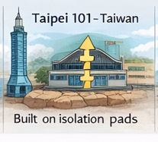
  - Balances the building when the ground shakes.

- Sabiha Gökçen Airport – Turkey
  - Built on isolation pads (base isolators).

  - Let’s the building move with the ground and reduces damage.

- Transamerica Pyramid – USA
  - Strong steel frame and design that distributes forces.
  - Building bends without breaking during earthquakes.
- San Francisco–Oakland Bay Bridge – USA
  - Rubber bumpers and special joints allow movement.
  - Bridge does not break even if the ground shakes.
- Traditional Japanese Pagodas – Japan
  - Use central pillar (shinbashira) to stay upright.
  - Pillar acts like a shock absorber during shaking.
Summary
Earthquakes happen due to movements in the Earth’s crust. Mechanical waves carry energy, shaking the ground and affecting buildings. Forces like lateral, vertical, torsional, and inertia act on structures. Building safety is important to prevent collapse, protect lives, and reduce damage. Engineers design buildings with flexible structures, base isolators, reinforced materials, and cross bracing to resist earthquake forces. Understanding earthquake mechanics and building safety helps us prepare for earthquakes and save lives.

